CS 255 System Design Document Template

UML Diagrams

UML Use Case Diagram
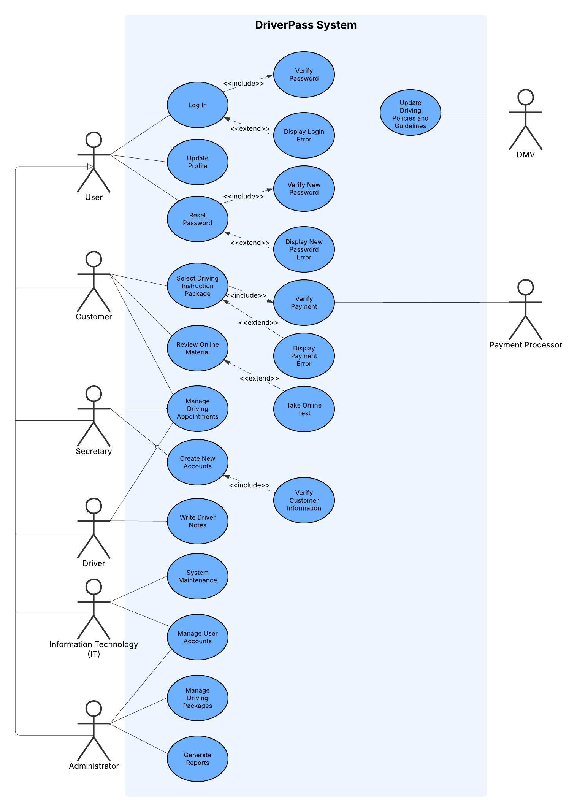

UML Activity Diagrams
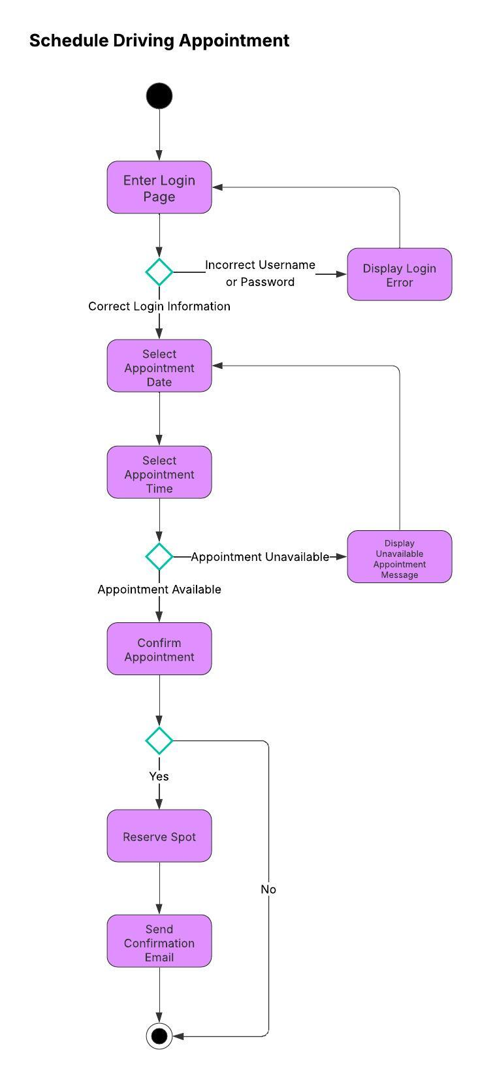
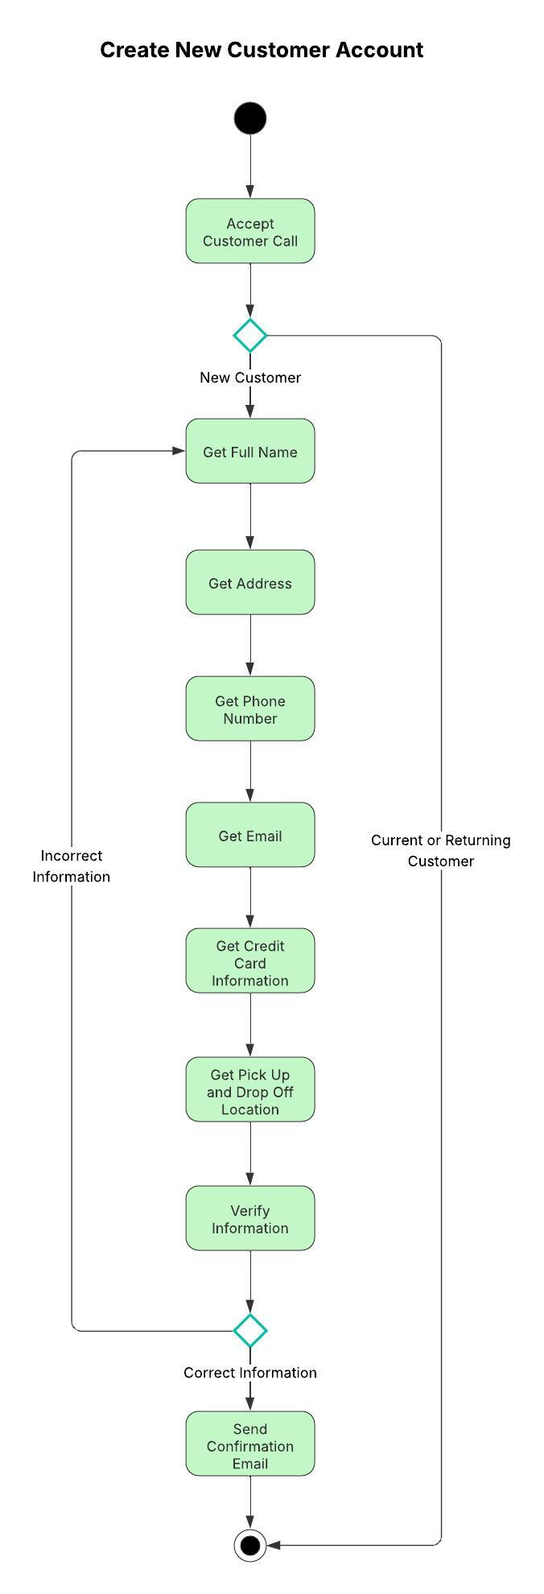

UML Sequence Diagram
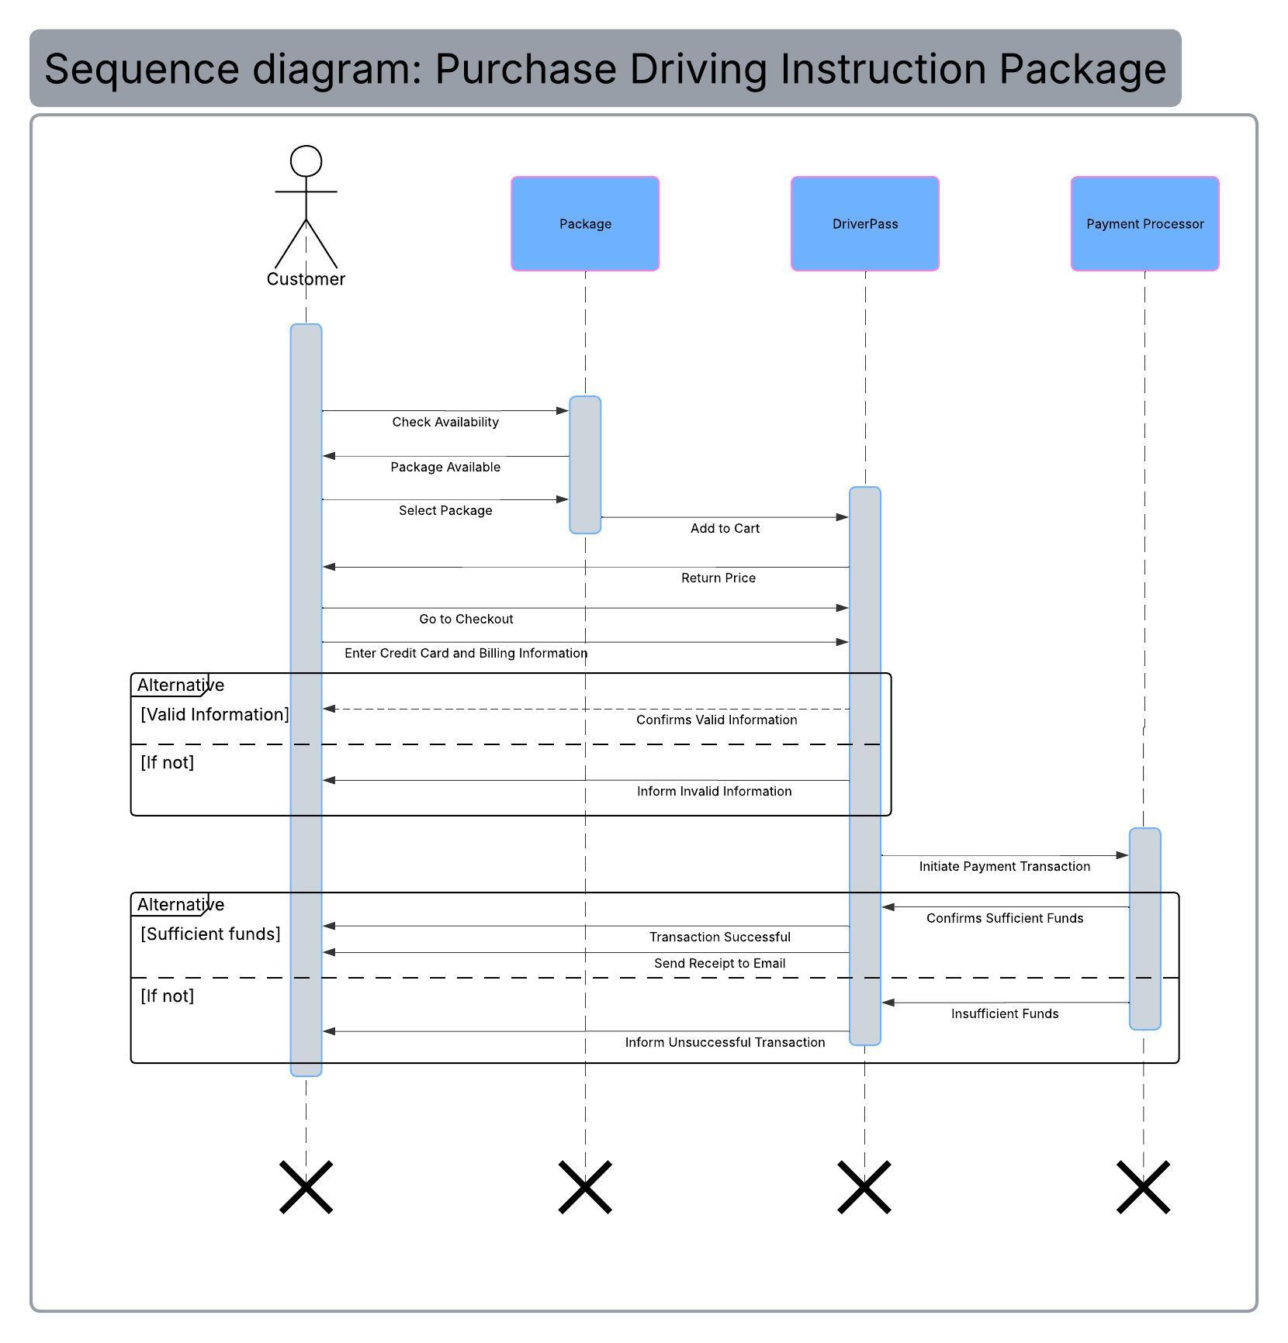

UML Class Diagram
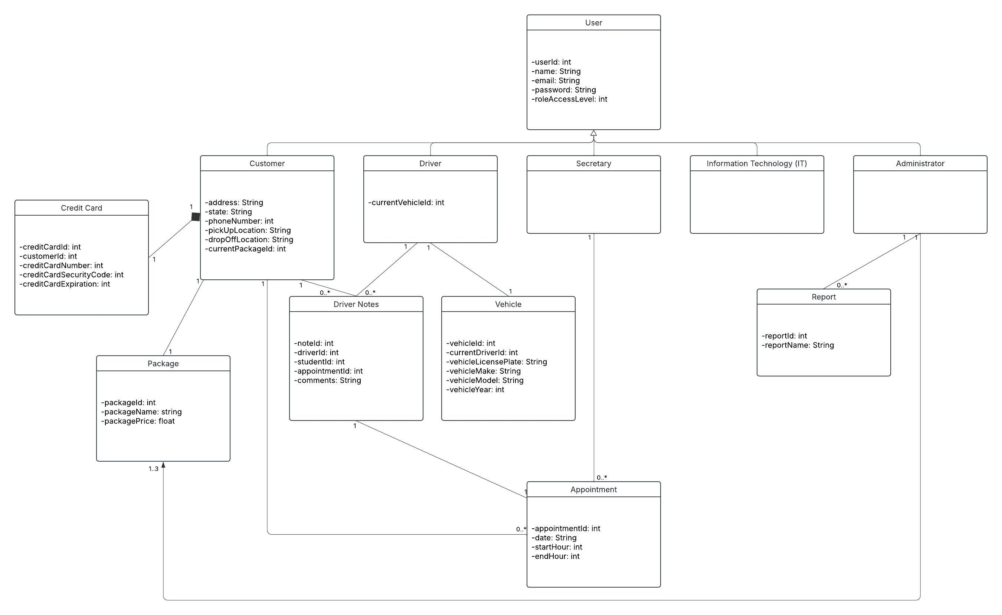

Technical Requirements

As DriverPass server infrastructure will be utilizing the cloud, a provider, such as Amazon Web Services (AWS), will be used. This arrangement will allow pay-as-you-go pricing for scalable servers and storage while not having to physically maintain server infrastructure. Additionally, AWS usage will have access to simple storage as well as SQL and NoSQL databases. For the software side, the servers can be run on Linux, an operating system that can be run for free at the enterprise level. Its open-source nature allows it to be closely watched by the community, facilitating faster vulnerability detection and patch deployment. This makes the Linux environment perfect for highly sensitive data that the DriverPass system will contain and manage.

On the client side, a modern PC, Mac, or smart phone with access to an updated browser is sufficient to access DriverPass resources. Using the latest versions of the respective operating systems is highly recommended, but versions that are not at the end of their lifecycle will suffice as well. However, internet is mandatory for the webapp to be functional.

DriverPass development will be conducted on any modern computer with VS Code to allow for maximum compatibility when switching devices to code on. Version control will also be implemented to record file changes, track development history, and have access to previous working versions of the project. The ability to branch the codebase to work on updating code or new features before merging with the production line will enable faster changes to the system.

